Photocopiable notes 1.1
Aim: To revise the motivations behind travel
and tourism.
Time: 10–15 minutes
Grouping: Ideally pairs, although other groupings and 1:1s with the teacher are possible. If you have an odd number of students, you could form a pair with one student.
Preparation: Copy and cut up a set of cards for each pair.
Procedure
• Explain to students they are going to revise the reasons and motivations behind travel for work and pleasure. First, ask students if they can remember the factors discussed on pages 8–9 of the coursebook.
• Put students into pairs and give each pair a set of cards. Ask students to spread the cards out face down in front of them.
• Students take turns to pick a card and read out the description on it. Their partner guesses which motivation factor it relates to (the answer is given at the bottom of each card.) Monitor while they are working and give help with any unfamiliar vocabulary as needed.

Homework or extension option
Ask students to choose two of the reasons for travel and write their own situations illustrating each one. They then carry out the same activity with their own situations in a future lesson.
Photocopiable notes 1.2
Aim: To practise dealing with numbers and statistics.
Time: 15–20 minutes
Grouping: Ideally pairs, although other groupings and 1:1s with the teacher are possible. If you have an odd number of students, you could form a pair with one student.
Preparation: Copy and cut up a set of cards for each pair.
Procedure
• Put students into pairs and give one a Student A card and the other a Student B card. Explain that they each have information on a country’s transport networks but will need to ask each other questions to obtain the missing statistics.
• Allow students time to read the information
on their cards before starting the activity.
Student As ask their questions first and after both students have taken their turn, they check their answers (marked in bold) with each other.

Homework or extension option
Students write a short article introducing their own country’s transport system (or one of their choice) using at least five to ten items of data. (150–200 words)

Photocopiable activity 1.1
card activity: why do we travel?
Student A

Cruising allows people to relax while their children take part in activities. They can please themselves, knowing they are safe, and wake up every day in a different place.  [amusement] | Many people travel regularly by train between London and Paris. It takes longer than flying but they can work on the train and they don’t waste valuable time going to and from airports.  [business] | Increasingly, older people are taking language classes after they retire in order to go on holidays where they can learn about different cultures and try out their new language skills.  [education]
Spa towns became popular as it was thought that drinking the mineral waters would cure ailments. Today they offer different types of therapy in a relaxing environment.  [health] | Pilgrimages were the origin of today’s annual holiday as people travelled long distances to a place where they would stay for some time in order to recharge their spiritual batteries.  [religion] | For those who live outside the major towns it’s an opportunity to stay in a large city and stock up on consumer goods that are not available in their home town.  [shopping]
Tournaments are a popular way of being a spectator while visiting a new country, though, as London learned in 2012, it does not always lead to increased visitor numbers.  [sport] | Economic migration, particularly to America and Australia, means that people often use their vacation time to see people they cannot see the rest of the time.  [visiting family] | Theme parks based around a specific idea such as the animal world, fairy tales or dinosaurs provide many attractions, activities, and buildings in one location.  [amusement]

Photocopiable activity 1.1
card activity: why do we travel?
Student B

Online booking allows customers to book at home but travel agents can offer a personalized service for travellers who haven’t got time to make their own arrangements.  [business] | While a holiday usually means heading for the beach, people are increasingly using their vacation time to learn a skill such as singing, swimming or even learning to ride a bike.  [education] | It is becoming increasingly common to travel abroad in order to have treatment that is either not available or too expensive at home.  [health]
Certain cities and sites around the world become the focus at particular times of the year for thousands of visitors who hope to gain wisdom and spiritual improvement.  [religion] | Many airlines offer weekend breaks with accommodation in a prime city location and plenty of time for retail therapy! The savings made overseas can make the cost of the trip worthwhile.  [shopping] | Thrill seekers and those who enjoy pushing themselves to the limit of safety and beyond are catered for by holidays focusing on extreme activities such as potholing and bungee jumping.  [sport]
For some people the journey is a holiday in itself; a long train journey such as the Trans-Siberian Express offers the opportunity to have a holiday while travelling long distance.  [amusement] | Meeting rooms, video-conferencing facilities, high-speed internet access, 24-hour room service and same-day laundry are essential to travellers, along with proximity to travel networks.  [business] | Many holidaymakers are looking to exercise their minds and bodies and among the fastest-growing types of holiday involving learning a new skill are dancing and exotic cookery.  [education]
Photocopiable activity 1.2
Card activity: Facts and figures exchange
Student A

Part 1
India is the second most heavily populated country in the world, with a population of over 1.2 billion. It is also of enormous size, covering an area of over 3 million km², making it the seventh largest country in the world. With an extremely varied landscape including mountainous regions, forests, coastal plains and desert, moving people around this vast country presents a great challenge to transport networks. India has over 3 million km² of roads and those who prefer to travel by rail (over 30 million every day) are served by 63,974 km of railways linking over 7,000 stations. Some of these stations also have interesting statistics: for example, Ghum Station in Darjeeling is the highest hill station at an altitude of 2,258 m, while Kharagpur Station in West Bengal has the longest platform at
1027.5 m. In fact, this is the longest railway platform in the world! Proportionate to its size, India has relatively few airports; there are 351 airports, giving it a ranking of 22nd in the world after much smaller countries such as the UK with 462 airports and Papua New Guinea with 562. India does, however, have 14,500 km of waterways, used for both personal and commercial transport.
Part 2
The world’s largest island, Greenland, has an area of ¹_______ and a population of just ²_______ , making it the least densely populated country in the world. As ³_______ of the country lies beneath the Greenlandic ice cap, most people live along the south-west coast and around ⁴_______ of them live in the capital, Nuuk. A startling statistic is that there are only ⁵_______ of roads in Greenland; outside towns there are no roads at all. There is also no passenger rail network; there was once a ⁶_______ narrow gauge railway at Qoornoq used in the fish drying industry but this closed over ⁷_______ years ago. The traditional means of crossing land is by dog sled, while for longer distances travel is mainly by air or by sea. Greenland has ⁸_______ airports (the same as Cyprus, which has an area of ⁹_______), making it ¹⁰_______ in the world ranking. Most of the airports can only handle small aircraft; the largest aircraft operating internal flights can carry up to ¹¹_______ passengers. International flights using larger planes land at Kangerlussuaq in the west, ¹²_______ from Nuuk, or Narsarsuaq in the south, ¹³_______ away. Passengers then fly to their destination by small plane or helicopter. Local people travel by boat between coastal towns and cruise ships call in at the major ports.

Photocopiable activity 1.2
Card activity: Facts and figures exchange
Student B

Part 1
India is the second most heavily populated country in the world, with a population of over ¹_______. It is also of enormous size, covering an area of over ²_______ , making it the seventh largest country in the world. With an extremely varied landscape including mountainous regions, forests, coastal plains and desert, moving people around this vast country presents a great challenge to transport networks. India has over ³_______ of roads and those who prefer to travel by rail (over ⁴_______ every day) are served by ⁵_______ of railways linking over ⁶_______ stations. Some of these stations also have interesting statistics: for example, Ghum Station in Darjeeling is the highest hill station at an altitude of ⁷_______, while Kharagpur Station in West Bengal has the longest platform at ⁸_______. In fact, this is the longest railway platform in the world! Proportionate to its size, India has relatively few airports; there are ⁹_______ airports, giving it a ranking of ¹⁰_______ in the world after much smaller countries such as the UK with ¹¹_______ airports and Papua New Guinea with ¹²_______. India does, however, have ¹³_______ of waterways, used for both personal and commercial transport.
Part 2
The world’s largest island, Greenland, has an area of 2.17 million km² and a population of just 57,695, making it the least densely populated country in the world. As 81% of the country lies beneath the Greenlandic ice cap, most people live along the south-west coast and around 25% of them live in the capital, Nuuk. A startling statistic is that there are only 150 km of roads in Greenland; outside towns there are no roads at all. There is also no passenger rail network; there was once a 600 mm narrow gauge railway at Qoornoq used in the fish drying industry but this closed over 30 years ago. The traditional means of crossing land is by dog sled, while for longer distances travel is mainly by air or by sea. Greenland has 15 airports (the same as Cyprus, which has an area of 9,251 km²), making it 148th in the world ranking. Most of the airports can only handle small aircraft; the largest aircraft operating internal flights can carry up to 50 passengers. International flights using larger planes land at Kangerlussuaq in the west, 319 km from Nuuk, or Narsarsuaq in the south, 465 km away. Passengers then fly to their destination by small plane or helicopter. Local people travel by boat between coastal towns and cruise ships call in at the major ports.

Photocopiable notes 2.1
Aim: To revise web words.
Time: 10–15 minutes
Grouping: Ideally pairs, although other groupings and 1:1s with the teacher are possible. If you have an odd number of students, you could form a pair with one student.
Preparation: Copy and cut up a crossword for each pair.
Procedure
• Students work in pairs to complete the crossword.
• When they have finished, they could check their answers with another pair before you go through the answers with the class.

Answers
Across
2 home page 3 layout 4 graphic 6 scroll
9 bandwidth 10 font
Down
1 menu 3 load 5 crash 7 cursor 8 link
9 byte

Homework or extension option
Students write a short article describing the process of using a website as they would explain it to someone new to computing, using as many items of vocabulary from the crossword as possible. (150–200 words)

Photocopiable notes 2.2
Aim: To revise collocations related to a web advertising campaign.
Time: 10–15 minutes
Grouping: Ideally pairs, although other groupings and 1:1s with the teacher are possible. If you have an odd number of students, you could form a pair with one student.
Preparation: Copy and cut up a set of cards for each pair, separated into piles of grey cards (nouns) and white cards (verbs).
Procedure
• Explain to students that they are going to revise collocations (word partnerships). Put them into pairs and give each pair a set of cards. Ask
them to spread the white cards out face up in front of them. and have the grey ones face down in a pile.
• Students take turns to pick up a grey noun card and find the verb cards in front of them that match the noun. There are three verbs for
each noun.

Answers
set aside / spend / waste money
interview / select / shortlist a candidate
host / record / upload a video
launch / mount / run a campaign
optimize / refresh / update a website

Homework or extension option
Students write a short account of a web advertising campaign that they have seen, using as many of the collocations in the exercise as possible.
(100–125 words)

Photocopiable activity 2.1
crossword: web words

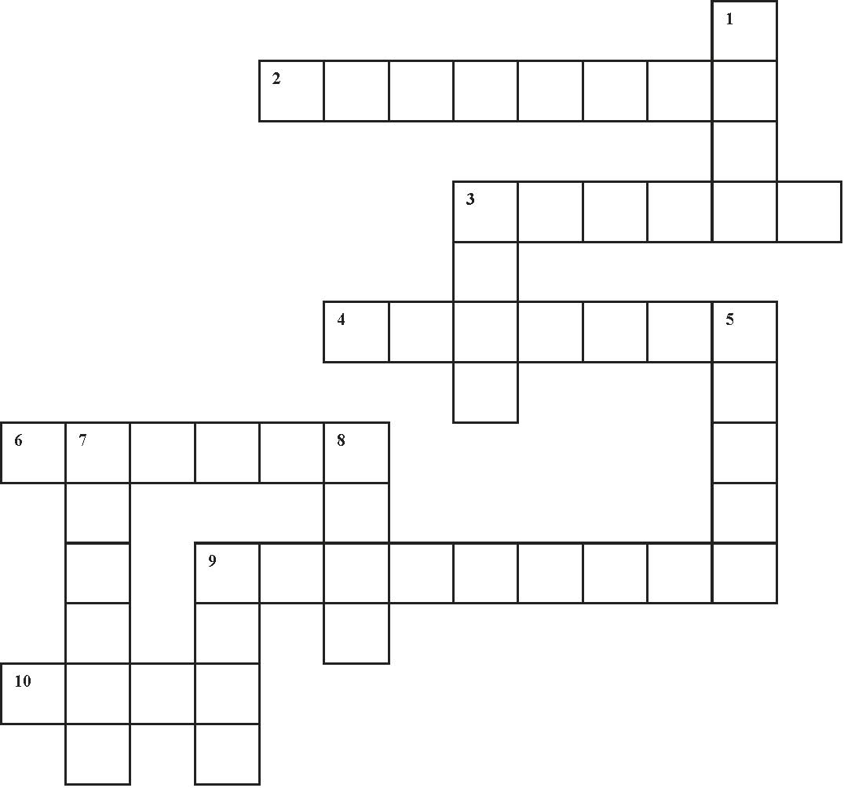

Across
2 The screen of a website that opens when you first visit the site is the ______.
3 The ______ is the way that text and images appear on the screen.
4 A picture or diagram that appears on a computer screen is often called a(n) ______.
6 If you ______ up or down, the information on the screen moves up or down.
9 The ______ of an internet connection is the amount of data it can transmit at one time.
10 The size and style of text displayed on a computer screen is the ______.

Down
1 The ______ is the list of choices that appears on a computer screen.
3 If you ______ a program into your computer, you transfer it from a remote server.
5 If your computer is not working properly, it may ______ and it will then stop working altogether.
7 A ______ is a mark, often an arrow, that you move around a computer screen using your mouse.
8 A ______ is a line of text or a picture that you click on to move to another part of the document or a new document.
9 A ______ is a unit of data stored on a computer, which is used to measure the size of a document.
Photocopiable activity 2.2
Matching activity: Web campaign collocations

waste | money
set aside | spend
shortlist | a candidate
interview | select
record | a video
upload | host
launch | a campaign
run | mount
refresh | a website
update | optimize

Photocopiable notes 3.1
Aim: To revise vocabulary related to describing hotels.
Time: 10–15 minutes
Grouping: Ideally pairs, although other groupings and 1:1s with the teacher are possible. If you have an odd number of students, you could form a pair with one student.
Preparation: Copy and cut up a set of cards for each pair and shuffle them.
Procedure
• Divide students into pairs. Give each pair a set of cards and ask them to spread them out face down in front of them.
• Students take turns to turn over three cards. The aim is to pick up a complete set of words from the same word family, e.g. inspire, inspirational, uninspiring.
• If a student wins a set of cards, they keep them and have another turn. At the end, the winner is the one with the most sets. To make the activity more challenging, do it against the clock – give students a maximum of ten minutes to finish.

Homework or extension option
Students write ten sentences about a hotel (either a hotel they know or one they have read about on a website), each using one of the
words from the word family. When they have finished, they compare their sentences in pairs before choosing the most interesting to read to the class.

Photocopiable notes 3.2
Aim: To revise elements of a business plan.
Time: 10–15 minutes
Grouping: Ideally pairs, although other groupings and 1:1s with the teacher are possible. If you have an odd number of students, you could form a pair with one student.
Preparation: Copy and cut up a set of cards for each pair and shuffle them.
Procedure
• Divide students into pairs. Give each pair a set of cards and ask them to spread them out face down in front of them.
• Students take turns to turn over two cards. The aim is to match elements of a business plan (grey cards) with their definitions (white cards).
• If the cards do not match, they put them back face down where they were. If a student wins a set of cards, they keep them and have another turn. At the end, the winner is the one with the most sets.
• Round up by eliciting the answers.

Homework or extension option
Students write a description of a business plan, placing each of the elements in the correct order and giving it a short description. (100–125 words) To make the activity longer, you could ask students to write a business plan following the model on page 29 of the coursebook.

Photocopiable activity 3.1
Matching activity: Word formations

inspire | inspirational | uninspiring
comfortable | discomfort | uncomfortable
distinguishing | indistinguishable | distinctive
depend | dependency | independent
emotion | emotive | unemotional
attend | attentive | attention
perceive | perception | imperceptible
consistent | consistency | inconsistent
innovate | innovation | innovative
different | differentiate | indifferent

Photocopiable activity 3.2
Matching activity: Business plan pairs

an overview of your business  idea presenting the key points | executive summary
a description of key  personnel outlining their roles, experience and expertise | management team
an indication of where your business will be situated and a description of the premises | location
the specific group of customers your business is aiming to attract | target clientele
how you intend to  promote your business | marketing plan
the risks and potential rewards  of your business venture | SWOT analysis
an outline of the fixed and variable costs for the first year’s activity | financial forecasts
a formal statement of how  much a business earns and  what it spends over one year | balance sheet
the amount of money available and an account of how it is to be spent | budget
when income and expenditure  are the same and the business starts to make a profit | break even

Photocopiable notes 4.1
Aim: To revise verb + noun collocations used when talking about meetings.
Time: 10–15 minutes
Grouping: Ideally pairs, although other groupings and 1:1s with the teacher are possible. If you have an odd number of students, you could form a pair with one student.
Preparation: Copy and cut up a set of cards for each pair and shuffle them.
Procedure
• Divide students into pairs. Give each pair a set of cards and ask them to spread them out face down in front of them.
• Students take turns to turn over two cards. The aim is to match the verbs (white cards) with the correct noun/noun phrase (grey cards) to form collocations used when talking about meetings.
• If the cards do not match, they put them back face down where they were. If a student wins a set of cards, they keep them and have another turn. At the end, the winner is the one with the most sets.
• Round up by eliciting the answers.

Homework or extension option
Students write ten sentences using the collocations in the exercise. You could also ask if there are any alternative collocations that can be formed, e.g. circulate minutes, set the agenda.

Photocopiable notes 4.2
Aim: To revise facts about the Brijuni Archipelago from the Case study.
Time: 15–20 minutes
Grouping: Ideally pairs, although other groupings and 1:1s with the teacher are possible. If you have an odd number of students, you could form a pair with one student.
Preparation: Copy a quiz for each pair.
Procedure
• Divide students into pairs and give each pair a copy of the quiz. They should have their coursebooks closed during this activity.
• Students work in pairs to complete the quiz.
• Round up by eliciting the answers. The winner is the student with most questions right.

Alternative suggestion
Divide the quiz into two parts of six questions each and give students the answers to the questions they are going to ask (give Student A questions 1–6 and the answers to 7–12, and Student B questions 7–12 and the answers to
1–6). Students ask each other the questions on their half of the quiz.
Answers
1 c 2 b 3 c 4 a 5 c 6 a 7 b 8 a 9 c
10 a 11 c 12 a

Homework or extension option
Students write a set of quiz questions on Goa, using the information on pages 32–33 of the Coursebook, to quiz each other in pairs in the next lesson. Alternatively, students could research another tourist resort on which to base their quiz.

Photocopiable activity 4.1
Card activity: Meeting collocations

set | a date
circulate | an agenda
come | to a decision
reach | agreement
go | round in circles
find | common ground
take | minutes
raise | a point
put | something to the vote
call | a meeting

Photocopiable activity 4.2
Quiz: The BrIjuni quiz

1 The Brijuni Archipelago consists of _____ islands.
a 10 b 12 c 14

2 The islands are part of _______.
a Slovenia b Croatia c Hungary

3 There is a safari park and a(n) _______ on Veliki Brijun.
a aquarium b bird sanctuary c zoo

4 There are over 200 dinosaur _______ on Mali Brijun.
a footprints b skeletons c varieties

5 _______ of the National Park’s protected area on Mali Brijun is under water.
a 40% b 60% c 80%

6 The Archipelago became a national park in _______.
a 1983 b 1993 c 2003

7 There are _______ plant species on the islands.
a 500 b 700 c 900

8 There are _______ varieties of birds.
a 250 b 500 c 750

9 There are three luxury hotels on _______ .
a Gruni b Mali Brijun c Veliki Brijun

10 Tourists may see _______ dolphins swimming around the islands.
a pink b blue c grey

11 An annual attraction is the _______ Festival.
a Seafood b Dance c Watersports

12 Endangered species growing on the islands include wild _______.
a cucumber b lettuce c mushroom

Photocopiable notes 5.1
Aim: To revise airport regulations using the passive.
Time: 15–20 minutes
Grouping: Ideally pairs, although other groupings and 1:1s with the teacher are possible. If you have an odd number of students, you could form a pair with one student.
Preparation: Copy and cut up a set of cards for each pair and shuffle them.
Procedure
• Divide students into pairs. Give each pair a set of cards and ask them to spread them out face up in front of them. They should sort them into two piles of questions (grey cards) and answers (white cards).
• Students work together to match the questions passengers commonly ask at airport security with the answers.
• Round up by eliciting the answers.

Alternative suggestions
To make the activity more challenging, give each student in the pair five question cards and five answer cards. They then take turns asking a question while their partner looks for the answer. Alternatively, give students the question cards only and get them to take turns to ask each other without having the answer cards to refer to.
Homework or extension option
Students write ten more question and answer exchanges on airport procedure, using the passive in each answer.
Photocopiable notes 5.2
Aim: To practise dealing with passenger complaints.
Time: 20–25 minutes
Grouping: Ideally pairs, although other groupings and 1:1s with the teacher are possible. If you have an odd number of students, you could form a pair with one student.
Preparation: Copy and cut up a set of cards
for each pair, divided into two sets of white
and grey cards.
Procedure
• Tell students that they are going to revise ways of dealing with passenger complaints at the airport.
• Put students into pairs. Give Student A the white cards and Student B the grey cards. (There are eight white and seven grey cards.) Student A starts.
• Students take turns to pick a card from their pile and, in the role of the passenger, put their complaint to their partner, who is the airport official who must deal with the complaint tactfully. Monitor and give help as needed with any difficult vocabulary, e.g. pacemaker, implant.
• Round up by asking pairs if their situations had a satisfactory outcome.

Alternative suggestion
Give both students all of the cards. They spread them out face up and choose whether to make or deal with the complaint in each situation.
Homework or extension option
Students choose one or two of the situations from the activity and extend the conversation to write a longer dialogue in which the passenger remains unsatisfied and wishes to pursue the complaint further (3–4 minutes). These could be practised in pairs in the next lesson.

Photocopiable activity 5.1
Matching activity: Airport exchanges

Excuse me, can you tell me if it’s allowed
to take a laptop on as hand baggage?
You’re restricted to one item of cabin baggage but
you can put your laptop inside your cabin bag.
I need to take my medicine during the flight but
it’s in a bottle. Can I take it on board with me?
Yes, essential medicines are permitted on board
if you have written authentication from your doctor.
I’ll have to feed my baby during the flight. She isn’t on
solid food yet – is liquid baby food allowed on board?
Yes, it can be taken on board but you’ll be required
to taste it to verify that it is genuine baby food.
I have dry skin, so I’d like to take my skin lotion
with me to use during the flight. Is that allowed?
You’re restricted to 100 ml of liquid per item, so
your lotion will have to be poured into a smaller
container. The rest must be placed in your hold luggage.
I know we’re not allowed to smoke on board but I’d like to take my lighter with me to use as soon as we land. Is that permitted?
Yes, one lighter per person is permitted in the cabin but
not in your baggage – it must be carried in your pockets at
all times. Lighters are not authorized in hold baggage.

Photocopiable activity 5.1
Matching activity: Airport exchanges

Couldn’t you make an exception? It’s just a little bottle ...
I’m afraid not. Security personnel are not
permitted to deviate from the security regulations.
Could you tell me what the security screening
involves at this airport? They’re all different.
Shoes must be taken off and placed
in the tray to go through the scanner.
I wear disposable contact lenses.
Do they count as liquid?
Contact lenses are permitted in cabin baggage as
long as they’re in their sealed original packaging.
Does my camera have to be screened?
I’m afraid the film will be damaged.
Don’t worry, your film will not be
damaged by the screening process.
I’m not keen on airline food. Is
food and drink allowed on board?
Any liquid must be in containers of not more than
100 ml and placed in a transparent plastic bag along
with toiletries. But the food on board is delicious!

Photocopiable activity 5.2
Card activity: What would you do/say?

Your flight was delayed for several hours because of bad weather and has now been cancelled. You are going to miss an important meeting. | You have a large suitcase. You did not pay in advance for hold baggage and you do not see why you should pay extra at the check-in desk. | You need to take  your own food onto the plane because  you have particular dietary requirements. You failed to advise the airline of this  in advance.
You were unable to find a disabled parking space close to the terminal and had to walk a much longer distance, making you late for check-in. | You’re on a domestic flight. It’s taking longer to go through security because domestic  and international passengers now  go through the  same channel. | A large group of sports fans are celebrating their team’s victory in the departure lounge. This is disturbing  other passengers.
You checked in late for your incoming flight. You caught your plane and have now arrived but your luggage has gone  to a different airport. | You’re told to remove your shoes at the security screening. You’re annoyed because not all airports require this. | You have missed your onward long-haul flight because your incoming flight was delayed. There isn’t another flight until tomorrow.
Your incoming flight was delayed by fog and rail services to the city centre have now stopped for the night. | A couple in the check-in area are arguing and not attending  to their three small children, who are annoying the other passengers. | Your flight has been transferred to another terminal at short notice and it’s a 30-minute walk to the new departure gate.
You have a pacemaker and do not wish to go through the body scanner because you do not accept that the scanner is safe for use with all metal implants. | You lost your temper because of the long check-in queues and shouted at the counter clerk, who refused to serve you. As a result, you missed your flight. | You have recently come out of hospital. You are in the departure lounge  and are feeling unwell. Your flight has  been delayed.

Photocopiable notes 6.1
Aim: To revise and extend knowledge of World Heritage sites.
Time: 15–20 minutes
Grouping: Ideally pairs, although other groupings and 1:1s with the teacher are possible. If you have an odd number of students, you could form a pair with one student.
Preparation: Copy and cut up a set of cards for each pair.
Procedure
• Tell students that they are going to revise the information on World Heritage sites in the coursebook and also test their knowledge of other World Heritage sites.
• Put students into pairs and give each pair a set of cards. Ask them to place the cards face down in a pile.
• Students take turns to pick a card and read out the information about a heritage site. Their partner decides if the information is true or false. If it is false, he/she should give a reason why. If the student’s answer is correct, they keep the card (the answer is given at the bottom of each card).
• Round up by checking how many cards each student collected.

Homework or extension option
Students research World Heritage sites (see http://whc.unesco.org) and write their own True/ False questions to ask each other in the next lesson. Five questions per student should be enough to have a class quiz.
Photocopiable notes 6.2
Aim: To revise forms used to talk about past habits and assumptions about the past.
Time: 10–15 minutes
Grouping: Ideally pairs, although other groupings and 1:1s with the teacher are possible. If you have an odd number of students, you could form a pair with one student.
Preparation: Copy and cut up a set of cards for each pair.
Procedure
• Tell students that they are going to revise ways of talking about the past using the information in the coursebook. They should have their books closed for this activity.
• Put students into pairs and give each pair a set of cards. Ask them to spread the cards on the table face up.
• Students take turns to pick three cards to assemble a sentence. They should do this
by looking for clues in the sentence structure; the information in the sentences will also
help them.
• Round up by eliciting answers. There may be alternative grammatically correct sentences but there is only one complete set of correct sentences (they are in the correct order on
the worksheet).

Homework or extension option
Students write ten sentences about historical places or World Heritage sites in their own country or ones that they researched in
activity 6.1. They then divide the sentences
into three parts as in this activity and create a
set of question cards to test each other in the next lesson.

Photocopiable activity 6.1
Card activity: Heritage true/false

Lake Baikal in Siberia contains 25 percent of the world’s unfrozen freshwater.  [False: 20 percent] | St Petersburg was known as Leningrad  for most of the  20th century.  [True] | When Vesuvius erupted, it buried the towns of Pompeii and Herculaneum.  [True]
World Heritage  sites may be cultural, natural or both.  [True] | The Sydney Opera House was designed by architect Frank Gehry.  [False: Jørn Utzon] | The 63 stone circles of Senegambia consist of over 1,000 monuments.  [False: 93 stone circles]
The Altamira Caves  are 30 km west  of Salamanca.  [False: Santander] | The entire island  of Mozambique is a World Heritage site.  [True] | Machu Picchu is one  of the greatest ancient sites in Argentina.  [False: Peru ]
The Galapagos Islands were one of the first World Heritage sites.  [True (in 1978)] | The Statue of Liberty in New York Harbour is a World Heritage site.  [True (since 1984)] | Kronborg Castle in Denmark is the setting  for Shakespeare’s Hamlet.  [True]
Te Wahipounamu is one of the most spectacular sites in Tahiti.  [False: New Zealand] | St Petersburg lies  on the river Volga.  [False: Neva] | The country with the greatest number of World Heritage Sites is Italy.  [True (47 sites)]
The northernmost  World Heritage site  is in Greenland.  [False: Wrangel Island  in the Arctic Ocean] | St Petersburg was  built on marshland.  [True] | Yellowstone National  Park in the USA recently became a World  Heritage site.  [False: in 1978]

Photocopiable activity 6.2
Card activity: Past tense matching

The Small Throne Room | was dedicated | to the memory of  Peter the Great.
The stone circles  at Stonehenge | may have been used | for the purposes  of astronomy.
Napoleon | may have been poisoned | with arsenic.
Ancient Egyptians | used to be buried with | a list of instructions  for the afterlife.
It is thought that | the Megalithic Temples of Malta are | the oldest buildings  in the world.
The Senegambia  stone circles | were carved | out of laterite.
The ruins at Vesuvius | were first excavated | in the 18th century.
The Sydney  Opera House | was designed | in 1957.
The Altamira Caves | are said to be | the earliest examples  of accomplished art.
Greenstone used at  Te Wahipounamu | was believed to have | spiritual force.
A variety of flora  and fauna | is supported by | the freshwater  in Lake Baikal.
Middle Age sieges | would | continue for many years.

Photocopiable notes 7.1
Aim: To revise ways of describing hypothetical situations.
Time: 15–20 minutes
Grouping: Ideally pairs, although other groupings and 1:1s with the teacher are possible. If you have an odd number of students, you could form a pair with one student.
Preparation: Copy and cut up a set of cards for each pair.
Procedure
• Put students into pairs. Give each pair a set of cards and ask them to place them face down in a pile in front of them. Explain that each card gives a situation where something has gone wrong with a planned event that could have been handled differently if the person had had more information.
• Students take turns to pick a card and read out the situation given. Their partner responds accordingly, using the hypothetical situations language on page 61 of the coursebook.
• Round up by eliciting responses to the different situations. Different answers are possible, depending on how students wish to handle the situation.

Homework or extension option
Students choose one or two of the situations and extend the conversation to make a short dialogue (2–3 minutes each). These could be practised in pairs in the next lesson.

Photocopiable notes 7.2
Aim: To revise expressions commonly used in contracts.
Time: 10–15 minutes
Grouping: Ideally pairs, although other groupings and 1:1s with the teacher are possible. If you have an odd number of students, you could form a pair with one student.
Preparation: Copy and cut up a set of cards for each pair.
Procedure
• Divide students into pairs. Give each pair a set of cards and ask them to spread them out face down in front of them.
• Students take turns to turn over two cards. The aim is to find pairs of terms with similar meanings to form collocations frequently used in contracts.
• If the cards do not match, students put them back face down where they were. If a student wins a set of cards, they keep them and have another turn. At the end, the winner is the one with the most sets.
• Round up by eliciting the answers.

Answers
terms and conditions
covenants and agreements
consent and approval
agree and accept
null and void
costs and expenses
organization and management
permits and licences
any and all
for and on behalf of

Homework or extension option
Students look online for the Legal or Terms and conditions page of an English language website and find as many of the terms in the exercise as they can. They may be able to find some more X and Y collocations. Alternatively, find one yourself, print it and make copies for the next lesson. A good example is the Pearson legal page at http://www.pearsoned.co.uk/Legalnotice.

Photocopiable activity 7.1
Card activity: What would you have done?

You are the organizer of a conference. The keynote speaker has missed his train and is due to speak in half an hour. You don’t have a copy of his presentation. | There are major roadworks on the main road leading to the hotel where the conference you are organizing is taking place. They are going to continue all weekend.
You are the event manager for  a wedding reception for 100 guests in one of the most prestigious hotels in town. The head chef has just resigned after  a row with the hotel manager. | You have organized a retirement dinner for the president of your local golf club tomorrow evening. You have just discovered that his wife has arranged a surprise party for him on the same evening.
It’s New Year’s Eve and you are  in charge of the fireworks display in your town. The weather forecast is for high winds and heavy rain, so it looks as if the event will  have to be cancelled. | Your boss has put you in charge of a launch party for your company’s latest product. The guest list of 500 includes representatives from the media. Today you learned that your competitors have launched a similar product ahead of yours.
You have organized a dinner  for a visiting delegation at your favourite restaurant. The restaurant has just failed its  health and safety inspection. | You have booked the venue for your annual conference, which is normally attended by around 600 people. Unfortunately, registrations are down this year and only 300 people are expected to attend.
You are responsible for corporate hospitality at a friendly match between your football club and  a visiting Italian club. Your  team captain fell and injured his knee while out running. | Your parents have booked  a family cruise to celebrate  your graduation. You don’t really want to go on a cruise and would rather go skiing with friends.

Photocopiable activity 7.2
MATCHING activity: LEGAL EXPRESSIONS

terms and | conditions
covenants and | agreements
consent and | approval
agree and | accept
null and | void
costs and | expenses
organization and | management
permits and | licences
any and | all
for and | on behalf of

Photocopiable notes 8.1
Aim: To revise adjectives describing personality.
Time: 15–20 minutes
Grouping: Ideally pairs, although other groupings and 1:1s with the teacher are possible. If you have an odd number of students, you could form a pair with one student.
Preparation: Copy and cut up a set of cards for each pair.
Procedure
• Divide students into pairs and give each pair a set of cards, separated into white cards (descriptions) and grey cards (adjectives). Ask students to place the white cards face down in a pile and spread the grey cards face up on the table.
• Students take it in turns to pick up a white card and look for a character adjective matching the description. In some cases, more than one adjective can be used to describe the person. When they have finished, all the cards should be used; they may be used more than once.
• Round up by eliciting answers. Discuss those with more than one adjective and ask students if they can explain the differences in meaning, e.g. Liz is versatile because she has different skills, helpful because the speaker suggests asking her for ideas, creative because she has good ideas – it is implied that she is talented.
• Also note that some of the adjectives may be positive or negative depending on the context, e.g. someone who is critical may be trying to be helpful or may be disapproving.

Suggested answers
Brian: critical; Carol: helpful; Christine: ambitious;
Colin: loyal; Diane: impatient; Fiona: outgoing;
Gary: reserved; Irene: adventurous, energetic;
James: cautious; Jill: stubborn; John: reliable,
responsible; Karen: methodical, thorough;
Linda: creative, talented, passionate,
imaginative; Liz: versatile, creative, talented,
helpful, imaginative; Mark: competitive,
determined, hard-working; Martin: sensitive,
tactful, considerate; Mike: perfectionist, thorough,
conscientious, hard-working; Tom: autonomous,
resourceful

Homework or extension option
Students choose one or two classmates and write descriptions of their characters for the next lesson without naming them. In pairs, they match the descriptions to character adjectives and then guess which class member is being described.
Photocopiable notes 8.2
Aim: To revise advice on preparing for a job interview.
Time: 10–15 minutes
Grouping: Ideally pairs, although 1:1s with the teacher are possible. If you have an odd number of students, you could form a pair with one student.
Preparation: Copy and cut up a set of cards for each pair and shuffle them.
Procedure
• Explain to students that they are going to revise advice given to candidates on preparing for an interview.
• Put students into pairs and give each pair a set of cards. Ask students to separate them into white cards (advice) and grey cards (the benefit of taking this advice). They should place the white cards in a pile face down and spread the grey cards face up on the table.
• Students take turns to pick a white card and read out the advice on their card. The pair then find the matching reason for giving this advice. When they have finished, they should have used up all the white and grey cards.
• There is only one way of matching all the cards, though there may be more than one match for one or two of the cards. Students may have to think again if they find themselves with a non-matching pair.

Homework or extension option
Ask students to write a short account of an interview they have had and to describe the preparation they did and how well they felt the interview went. If they have no previous interview experience or do not wish to disclose it, ask them to place themselves in the position of the interviewer and write an account of how they think he/she would prepare to interview a range of candidates. (100–150 words)

Photocopiable activity 8.1
Card activity: Personality adjectives
Descriptions

Brian upset a few people on the team because he pointed out all the problems with the new design. | Why don’t you ask Carol to do that  for you? She isn’t  busy and I’m sure  she won’t mind. | Christine has applied for a management post again this year. She tried last year but was told she didn’t have enough experience.
Colin has been with  the same company  for 20 years and hopes to stay until he retires as they’ve always treated him well. | Diane is easily bored – she always wants to get the job done quickly and move  on to the next one. | I think Fiona would make a good tour guide – she likes talking to people and enjoys company.
I’m not sure Gary is the best person to be a tour leader – he’s quite shy and doesn’t push himself forward. | Irene loves going on diving holidays –  I wouldn’t have the nerve. She loves  to be active! | James thinks the interview went well but he hasn’t resigned from his current job yet.
Jill is so sure she’s right that she won’t accept help from  others even when  she isn’t able to  finish the job herself. | You can depend on John – his work is of  a consistently high standard and he makes sensible decisions. | Karen likes to take  her time and check everything several times.
Linda’s a very good designer – she has ideas that wouldn’t occur to others and she loves her work. | Liz seems to be able to turn her hand to anything – she’s a good person to ask if you’re stuck for ideas. | Mark will make an excellent salesperson – he wants to be the best at whatever he does.
Why don’t you have  a word with Martin? He’s discreet and  he’ll understand  how you feel. | Mike has very high standards and won’t  be satisfied until everything is  done properly. | Tom is a self-starter who can work on his own without needing  to be told what to do.

Photocopiable activity 8.1
Card activity: Personality adjectives
Adjectives

adventurous | ambitious | autonomous
cautious | competitive | conscientious
considerate | creative | critical
determined | energetic | hard-working
helpful | imaginative | impatient
loyal | methodical | outgoing
passionate | perfectionist | reliable
reserved | resourceful | responsible
sensitive | stubborn | tactful
talented | thorough | versatile

Photocopiable activity 8.2
Matching activity: Interview preparation

Anticipate the questions  you might be asked | so that you can prepare  answers in advance when you  are not under pressure.
Find out as much as possible about  the company before the interview | so that you can appear  knowledgeable and show that you  are interested in the company.
Find out rates of pay if possible | so that you do not undersell yourself  or ask for too much if salaries are discussed at the interview.
Find out who is going to conduct  the interview and if it will be a 1:1 interview or a group interview | so that you know what to expect  and are not surprised on the day.
Find out about the interviewer’s position in the company | to give you an idea of how much decision-making power they have.
Get the person’s mobile  phone number if you can | in case there are any problems  on the day that make you late  for the interview.
Dress appropriately – neither  too casual nor over-dressed – | first impressions count and you will  be judged by your appearance even before the interview begins.
Highlight the skills you’ve mentioned  on your CV and give examples of  when and how you used them | to convince the interviewer that you have been honest and you really do have the skills you say you have.
Phone a few days after the interview to ask whether a decision has been made | to show that you are motivated  and really interested in the job.
If you have been  unsuccessful, ask why | so that you can prepare  better for the next interview.

Photocopiable notes 9.1
Aim: To revise and extend knowledge of national dishes and how they are made.
Time: 10–15 minutes
Grouping: Ideally pairs, although other groupings and 1:1s with the teacher are possible. If you have an odd number of students, you could form a pair with one student.
Preparation: Copy and cut up a set of cards for each pair.
Procedure
• You may wish to revise the dishes before starting the activity. They all appear in Unit 9 and most are described in detail. Burritos, sushi and chicken tikka masala are not – you could take the opportunity to explain these three dishes if you did not do this during the Culinary tourism reading activity on page 77.
• Explain to students that they are going to revise some of the dishes described in the coursebook and test their knowledge of
world cuisine.
• Put students into pairs and give each pair a set of cards. Ask them to spread the cards out face down in front of them.
• Students take turns to pick a card and read out the question on their card. Their partner guesses the name of the dish and the country/region where it originated (the answer is given at the bottom of each card).

Homework or extension option
Ask students to write two similar descriptions, one of their own national dishes and another of their choice. They can then test each other in pairs or in a larger group in the next lesson.

Photocopiable notes 9.2
Aim: To practise giving and responding to feedback.
Time: 15–20 minutes
Grouping: Ideally pairs, although other groupings and 1:1s with the teacher are possible. If you have an odd number of students, you could have more than one staff member receiving feedback.
Preparation: Copy and cut up a set of cards for each pair.
Procedure
• Explain to students that they are going to practise giving feedback in response to complaints made by restaurant customers. You may wish to go over the criteria for a successful restaurant experience on page 80 of the coursebook and the language in the Professional skills section on page 81 before starting the activity.
• Put students into pairs and give each pair a set of cards. Explain that there are two situations and that they are going to take turns to give and receive feedback. In each situation, a customer has complained about their experience in the restaurant where the students work.
• Allow students a couple of minutes to read the information on their cards. Student A begins and takes the part of the restaurant manager who has to give feedback to his/her staff based on the customer’s comments. Student B is a member of staff on duty in the restaurant on the night in question. Student B can respond in any way he/she wishes, bearing in mind that Student A is the boss!
• When they have finished, they swap roles and roleplay Situation 2.
• Round up by discussing how successful the outcome was in each situation.

Alternative suggestion
Give both students the complaint in each situation. The student receiving the feedback should think of reasons why the situation occurred and be ready for the feedback.
Homework or extension option
Students write an account of an occasion when they complained about an unsatisfactory restaurant experience and how the complaint was dealt with. (100–150 words)

Photocopiable activity 9.1
Card activity: What’s the dish?

This dish consists of a combination of meat, cheese and beans which is wrapped in a piece of thin, flat bread made from wheat flour. The name of the dish depends on whether the wrap completely encloses the filling.  [Burritos and tacos: Mexico] | This is a hot, spicy dish of meat  and vegetables, stewed with red peppers and seasoned with paprika. It’s usually served with noodles and  is very good on a winter day.  [Goulash: Hungary]
This is a dish for sharing –  perfect for parties. In the centre of  the table is a pot of melted cheese, sitting over a burner to keep it  hot. Guests dip cubes of bread  into the mixture using a long fork.  [Fondue: Switzerland] | It’s a dish consisting of cooked rice and pieces of raw fish mixed with vinegar and formed into little cakes, served cold. The presentation is very important and because the fish is raw, it must be served completely fresh.  [Sushi: Japan]
This dish is often served as a starter. The mussels are steamed and then stuffed with a spicy mixture of rice and chopped onions. The stuffed mussels are then cooked over a low fire. Delicious for seafood lovers!  [Midye dolmasi: Turkey] | Pieces of chicken are marinated in yoghurt to tenderize them and then baked and served in a spicy sauce. The ingredients of the sauce vary from one region to another but it  is always hot and creamy.  [Chicken tikka masala: India]
This is a vegetable soup usually served cold. Traditionally, the soup is tomato-based and includes stale bread as one of the main ingredients, though today there are many varieties including avocado and watermelon.  [Gazpacho: Spain (Andalucía)] | This is a traditional fish stew using several different types of fish. First, vegetables, including onions or leeks, are sautéed and then the fish, cut into cubes, is added along with water and brought to the boil, then simmered to make a thick stew.  [Bouillabaisse: France (Marseilles)]

Photocopiable activity 9.2
Card activity: Restaurant feedback
Student A

Situation 1
You are the senior manager of Petruchio’s, a popular Italian restaurant. You have received an angry telephone call from a customer complaining about his/her experience in your restaurant last night.
First, analyse the customer’s complaint in terms of the different criteria
for a successful restaurant experience (atmosphere, background music, etc.). Then discuss the problem with the duty manager who was in the restaurant last night. Give them the customer’s feedback and decide how to handle the situation. In your feedback remember to:
• create a dialogue
• choose the right time
• put forward solutions
• use the feedback sandwich
• include positive feedback
• focus on the problem, not the person.
The complaint
‘I booked a table at your restaurant last night to celebrate my partner’s new job. It was a special occasion and we were both looking forward to it as Petruchio’s is very popular. The table was booked for 8.00 but when we arrived, we were advised that the table was not yet free and we were asked to take a seat in the waiting area. When we were still waiting half an hour later, I enquired what was happening and an embarrassed receptionist admitted she had not realized we were there and had given our table to someone else. We were given a table at the back of the restaurant near the kitchen entrance, which was noisy and hot. We were offered complimentary starters by way of apology, which we accepted. When the waiter came to take our order, we asked about the house special but were told they were finished for the night. I ordered pan fried halibut and my partner ordered a grilled steak, which arrived five minutes after my fish and was tough. We both had pannacotta for dessert, which was delicious. When I asked for the bill, I noticed that it included the starters which we had been offered on the house. The waiter we spoke to earlier in the evening had gone off duty. After an embarrassing discussion in front of other diners, we paid the full amount.’

Photocopiable activity 9.2
Card activity: Restaurant feedback
Student B

Situation 2
You are the manager of Zorba’s, a Greek restaurant in the city centre. You have received a letter of complaint from a customer who is disappointed at the way his/her family were treated in your restaurant, which they felt was embarrassing and not up to the standard they expected.
First, analyse the customer’s complaint in terms of the different criteria
for a successful restaurant experience (atmosphere, background music, etc.). Then discuss the problem with the waiter who served the family on Saturday. Give him/her the customer’s feedback and decide how to handle the situation. In your feedback remember to:
• create a dialogue
• choose the right time
• put forward solutions
• use the feedback sandwich
• include positive feedback
• focus on the problem, not the person.
The complaint
‘I arranged a family dinner for nine people at your restaurant on Saturday evening. I booked your ‘special occasion’ set menu, which, according to your website, is available for parties of eight or more people. When we arrived, the restaurant had not arranged a table that could accommodate nine people and we had to wait while they rearranged the tables, causing some disturbance to other diners. When we asked for the children’s menu, we were advised that if we had the children’s menu for the four children in our party, that would mean fewer than eight people would be eligible for the special occasion menu and we would have to choose from the à la carte menu. Faced with the choice of accepting this or leaving, we decided that the children would choose from the set menu. The food was good but not really suitable for younger diners. The service was slow because the restaurant was busy and the children became bored. The music was also rather loud and we had to raise our voices to talk to each other. Although your restaurant claims to be family-friendly, we were left with the impression that children were not very welcome and we did not feel that the occasion was very special!’

Photocopiable notes 10.1
Aim: To revise and extend knowledge of risks involved in extreme sports.
Time: 10–15 minutes
Grouping: Ideally pairs, although other groupings and 1:1s with the teacher are possible. If you have an odd number of students, you could form a pair with one student.
Preparation: Copy and cut up a set of cards for each pair.
Procedure
• Explain to students that they are going to revise the extreme sports mentioned in the coursebook and learn some of the risks involved in them.
• Put students into pairs and give each pair a set of cards. Ask students to spread the cards out face down in front of them.
• Students take turns to pick a card and read out the risky situation on it. Their partner guesses which extreme sport it relates to (the answer is given at the bottom of each card).

Homework or extension option
Ask students to choose two of the extreme sports and write their own situations illustrating each one. They then carry out the same activity with their own situations in a future lesson. Alternatively, ask them to choose different extreme sports (an internet search for extreme sports will list many).
Photocopiable notes 10.2
Aim: To revise the key vocabulary of Unit 10.
Time: 15–20 minutes
Grouping: Ideally pairs, although other groupings and 1:1s with the teacher are possible. If you have an odd number of students, you could form a pair with one student.
Preparation: Copy and cut up a set of crosswords for each pair.
Procedure
• Divide students into pairs and give each pair a set of crosswords for Student A and Student B. Explain that they have two halves of the same crossword and each one has some answers and some blank spaces. Their aim is to complete the crossword by asking and answering questions to fill in the blanks.
• There are no clues provided; students should provide their own clues, either by defining the missing word in their own words or by illustrating it in a sentence where ‘X’ represents the missing word, e.g. We’ve done everything we can to (X) the risk but we can’t anticipate every kind of risk.’ (answer: mitigate)
• Students take turns to ask and answer questions to complete their half of the crossword.
• Round up by eliciting the answers.

Answers
Across
2 extinguisher 7 negligence 8 evacuate
9 trip 11 spill 12 electrocution
Down
1 mitigate 3 hazard 4 maintenance 5 civil
unrest 6 infection 10 poison

Homework or extension option
Students write 12 sentences using the words in the crossword. In the next lesson, select the most interesting ones that best illustrate the meaning of the words.

Photocopiable activity 10.1
Card activity: What’s the extreme sport?

The two men were last seen ascending the treacherous North Face. When the weather deteriorated, visual contact was lost and the emergency team were unable to begin searching for them until first light.  [mountaineering] | The pilot didn’t realize quickly enough that they were being blown off course and they narrowly avoided drifting into power cables. If that had happened, it’s unlikely there would have been any survivors. As it is, they escaped with a severe fright.  [hot-air ballooning]
Your height and weight are measured to ensure the cord is the correct length and elasticity and there are strict safety procedures. However, the fact is that once you jump, you’re on your own and if something goes wrong, serious injury is almost certain.  [bungee jumping] | The party were not properly equipped with helmets, torches and dry clothes and provisions in case they were underground longer than intended. When they finally did emerge, they were cold, wet and hungry.  [potholing]
I had a tandem jump strapped to an instructor, which was a great experience with minimal risk. It didn’t prepare me for going solo though – that involved a lot of training on a static line, which was not as exciting, but better training for when I had to jump by myself.  [skydiving] | Unfortunately, the reason it’s such an enjoyable sport is also the greatest risk. In this case the young rider was not strong enough to control her mount, who didn’t respond to her efforts to bring him to a safe halt and she was thrown over a hedge.  [horseback riding]
The problem was that my bindings were not properly adjusted. One of them came loose when I attempted to turn on a downhill run and I lost control. I was lucky to escape with a broken ankle.  [skiing] | Tragically, the teenager was pulled under by the force of the current and even though he was wearing a lifejacket and helmet, his leg was caught in rocks that were not visible from the surface and he drowned.  [whitewater rafting]

Photocopiable activity 10.2
CROSSWORD: risk

Student A

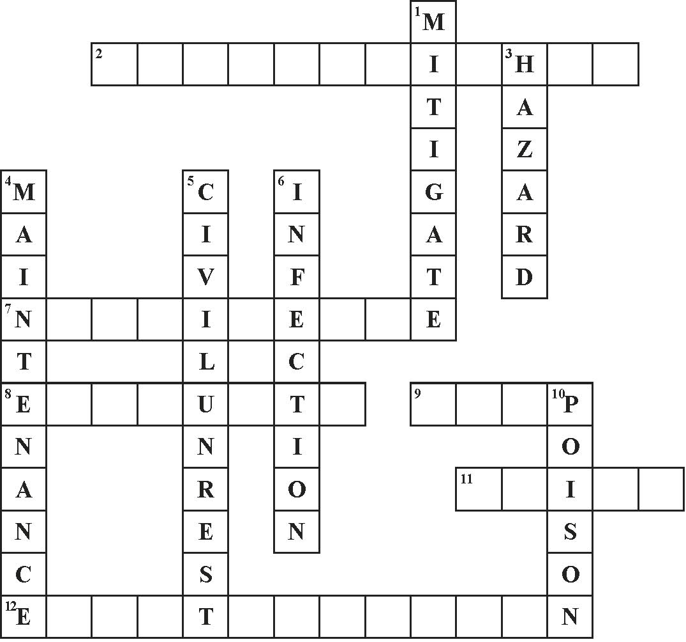

Photocopiable activity 10.2
crossword: risk

Student B

