These exercises are designed to evaluate students’ progress in assimilating the grammar and vocabulary from Units 1–5. They are suitable for either revision or testing.
For revision purposes, review the language area with the students in open class first and then allow students to work together in completing the exercises. Feed back as a class, asking for justification of the answer where appropriate.
For testing purposes, set a time limit for students to do one or more of the exercises individually in class. Alternatively, set the exercises as homework. If you choose to use these exercises for testing, it is worth first discussing with the students the best approach to each exercise, in particular reading a text to understand its overall meaning before attempting to complete the gaps. Take the answers in to correct or provide students with the answers to correct each other’s.
You may also wish to evaluate students’ progress in communicative performance. To do this, repeat one of the speaking/writing activities from the first five units. To increase the interest and challenge factors in this, change one or two features, e.g. students roleplay a different complaint for a hotel receptionist to deal with.
Tourism developments
Exercise 1, page 48
Ask students to do this first exercise without referring to the Grammar reference section. You could remind students of Generation X and Generation Y in the listening on page 14. They then read the text and underline the forms indicating a changing or developing situation.
is becoming, is getting, are travelling, are (increasingly) playing, are revealing
Continuous aspect
Exercise 2, page 48
Review continuous forms and refer students to the Grammar box on page 10 and page 111 of the Grammar reference section. Students work through the sentences, circling the correct option. In cases where both forms are correct, ask students to explain any difference in meaning.
1 are being built
2 has been growing
3 are being created
4 is being converted
5 are now becoming, both (has increased suggests that it is no longer increasing or that the speaker is only referring to a period up to the time of speaking, while has been increasing suggests that it is still increasing)
6 both (will offer suggests that the offer will be made once during the time period, while will be offering suggests a continuous offer for the whole month)
7 both (has risen suggests that it is no longer rising or that the speaker is only referring to a period up to the time of speaking, while has been rising suggests it is still rising)
8 travel, both (may fulfil means during the course of their lives; may be fulfilling means while they are travelling)
Ups and downs
Exercise 3, page 49
Refer students to page 12 of the coursebook if necessary to revise expressions used to describe trends. They then circle the incorrect option in each sentence.
1 gradually 2 slight 3 steadily 4 modest
5 levelled off 6 declined
Advertising and publicity
Exercise 4, page 49
Refer students to the definitions on page 16 of the coursebook. They then decide whether each of the sentences is referring to advertising or publicity.
1 A 2 P 3 A 4 P 5 P
Countable and uncountable nouns
Exercise 5, page 49
Check that students remember the meaning of the words in bold, which all appear in Unit 2.
They should decide whether the words are countable or uncountable in the context of the sentence, remembering that some words can be both, depending on how they are used. If necessary, refer them to the Grammar box on page 16 and pages 111–112 of the Grammar reference section.
1 U 2 C 3 U 4 U 5 U, C 6 C 7 C
8 U, U
Web words
Exercise 6, page 50
Ask students to find the web words in the word square and circle them. When they have finished, ask them to write a sentence with each of the words. If necessary, refer them to page 17 to check the definitions of each word.

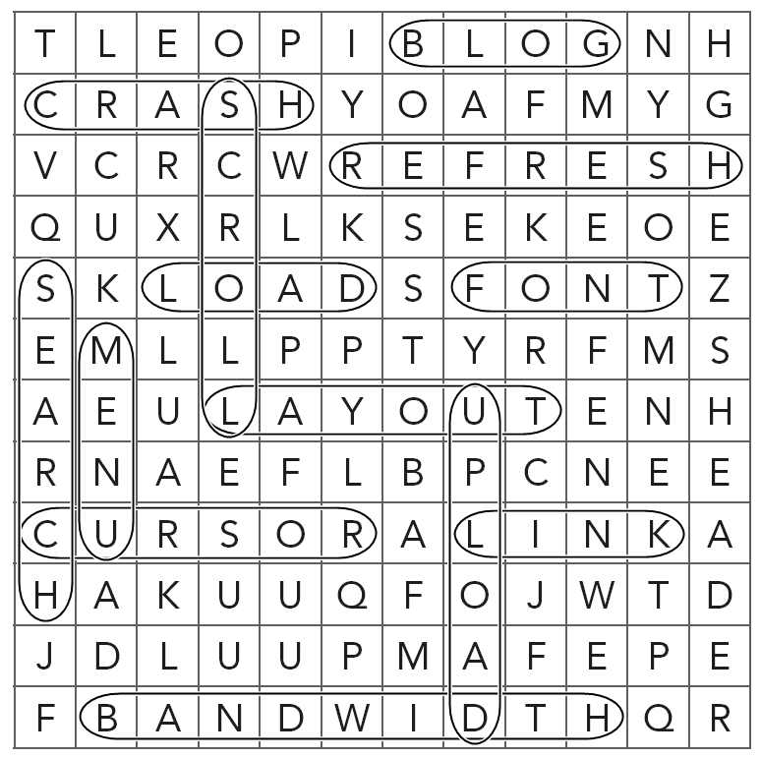

1 blog 2 crash 3 refresh 4 load 5 font
6 layout 7 cursor 8 link 9 upload
10 bandwidth 11 search 12 scroll 13 menu
Making predictions
Exercise 7, page 50
Review the expressions for making predictions
in the Grammar box on page 26 of Unit 3 and page 112 of the Grammar reference section. Students then complete the text with the expressions in the box.
1 bound to 2 chances are 3 likelihood
4 unlikely to 5 could 6 probably won’t
The business plan
Exercise 8, page 50
Refer students to the Professional skills box on page 28 and the extracts from a business plan
on page 29. They then complete the advice
about creating a business plan with the words in the box.
1 brand identity 2 overview 3 niche 4 cater
for 5 public relations 6 threats 7 forecasts
8 bottom line 9 profit and loss 10 break even
Branded vs boutique
Exercise 9, page 50
Remind students of work they did on branding in Unit 3 and the text about boutique hotels on page 25. They then complete the paragraph with the words in the box.
1 uninspiring 2 stylish 3 intimate
4 distinctive 5 attentive
Word formation
Exercise 10, page 51
Students have to fill each gap with a word formed from the word in capitals at the end of the line. Remind them that they did a similar exercise to this on page 25 but the vocabulary in this exercise revises the work of Unit 4.
1 leakage 2 flown 3 requirements
4 transferred 5 discontent 6 inappropriate
7 environmental 8 unsustainable
Key word transformations
Exercise 11, page 51
In this exercise students complete the second sentence using the word given so that it means the same as the first. They should not change the word given. Refer students to the Grammar box on reporting verbs on page 35, pages 112–113 in the Grammar reference section and the verb + noun collocations on page 36 for help if needed.
1 suggested (drastically) reducing
2 urged them / the meeting to take action / that action be taken
3 recommended strictly monitoring visitor
4 was warned not to sail
5 going round in circles
6 reach a decision unless
Dealing with difficult passengers
Exercise 12, page 51
Review the list of dos and don’ts for dealing with difficult situations on page 45. Students then complete the sentences to form expressions that can be used to calm down difficult passengers.
1 utmost 2 inconvenience 3 calm down
4 beyond 5 excuses 6 hear 7 passing
8 claim
The passive
Exercise 13, page 51
Review the rules for the passive on page 43 in Unit 5 and page 113 of the Grammar reference section and remind students of its use in official statements. Students then rewrite the sentences using the passive form of the verb in brackets.
2 He was denied entry because his passport had expired.
3 Stricter border controls have been enforced.
4 She complained because her medications
had been confiscated.
5 A new air traffic control system is being installed.
6 Passengers are restricted to one item of
cabin baggage.

